## Technical Documentation

**Before you start please ensure that your gitignore is setup correctly!**

Solutions currently in place for this section include restarting, so ensure following of steps

## **2.4 Define URI path and view**

* Open django_project urls.py to add a path below the admin path to include the specific urls that will be created in the the portfolio_app urls.py....
  + Just add the required code into the file using VS Code
* Update portfolio_app/views.py views by defining the following view for the home page.
  + Same here
* Create urls.py file in portfolio_app that contains a path to the defined view
  + For this step copy the urls from djangoproject into the portfolio app folder
  + Then edit the code
* Run Start server command-python manage.py runserver
  + This step may cause you issues. You may find you get an error where the module django_project is not found with a slew of other errors.
  + First try to ensure these steps work correctly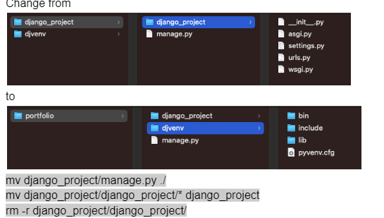
  + If the problem persists the solution i did was to delete everything and restart GE02 with the corrected commands djvenv\Scripts\activate for windows in portfolio folder
  + This is the only sure way that django installs correctly
* No extra steps needed for the rest of section 2.4